Huffman Coding

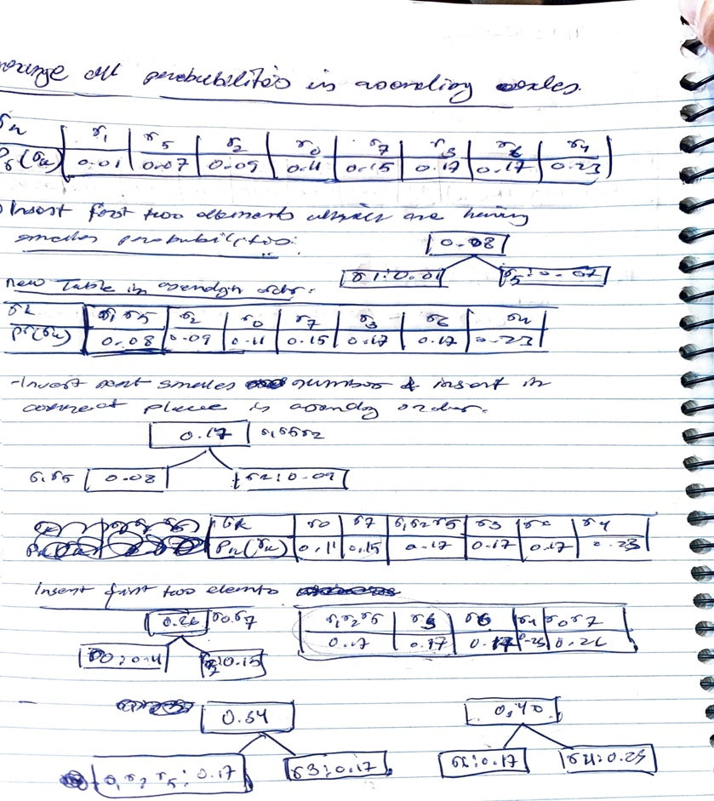

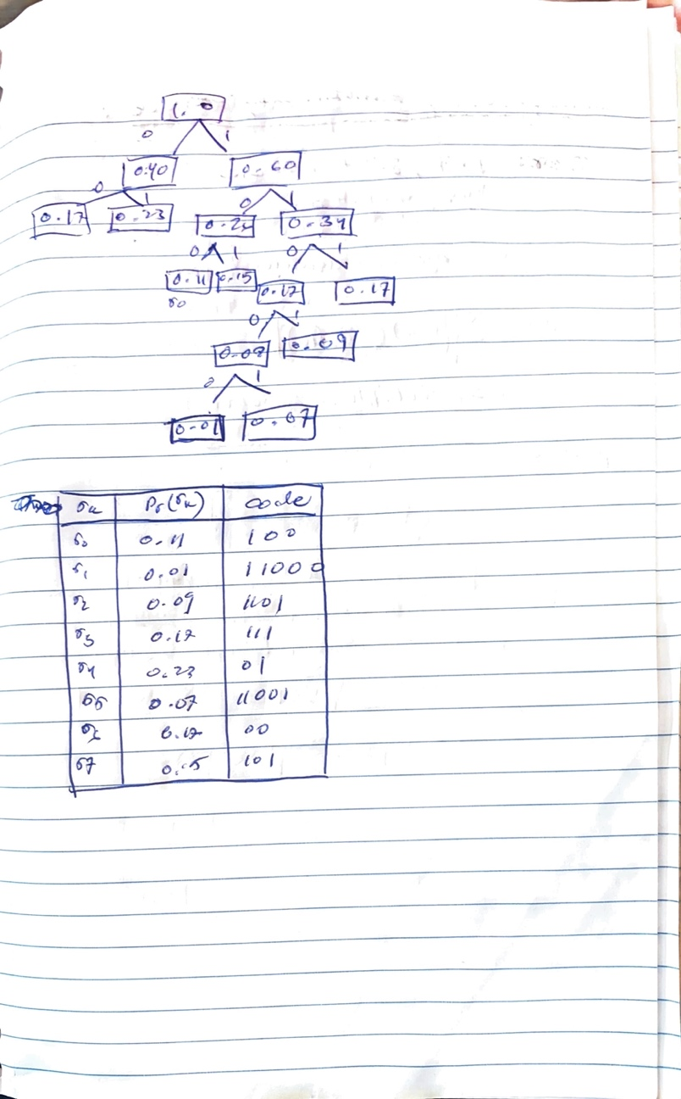

1. Compress the image using Huffman coding

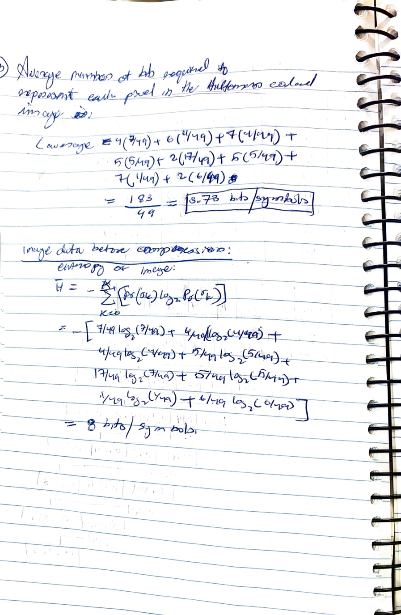

b. Compute the compression achieved and the effectiveness of Huffman coding.

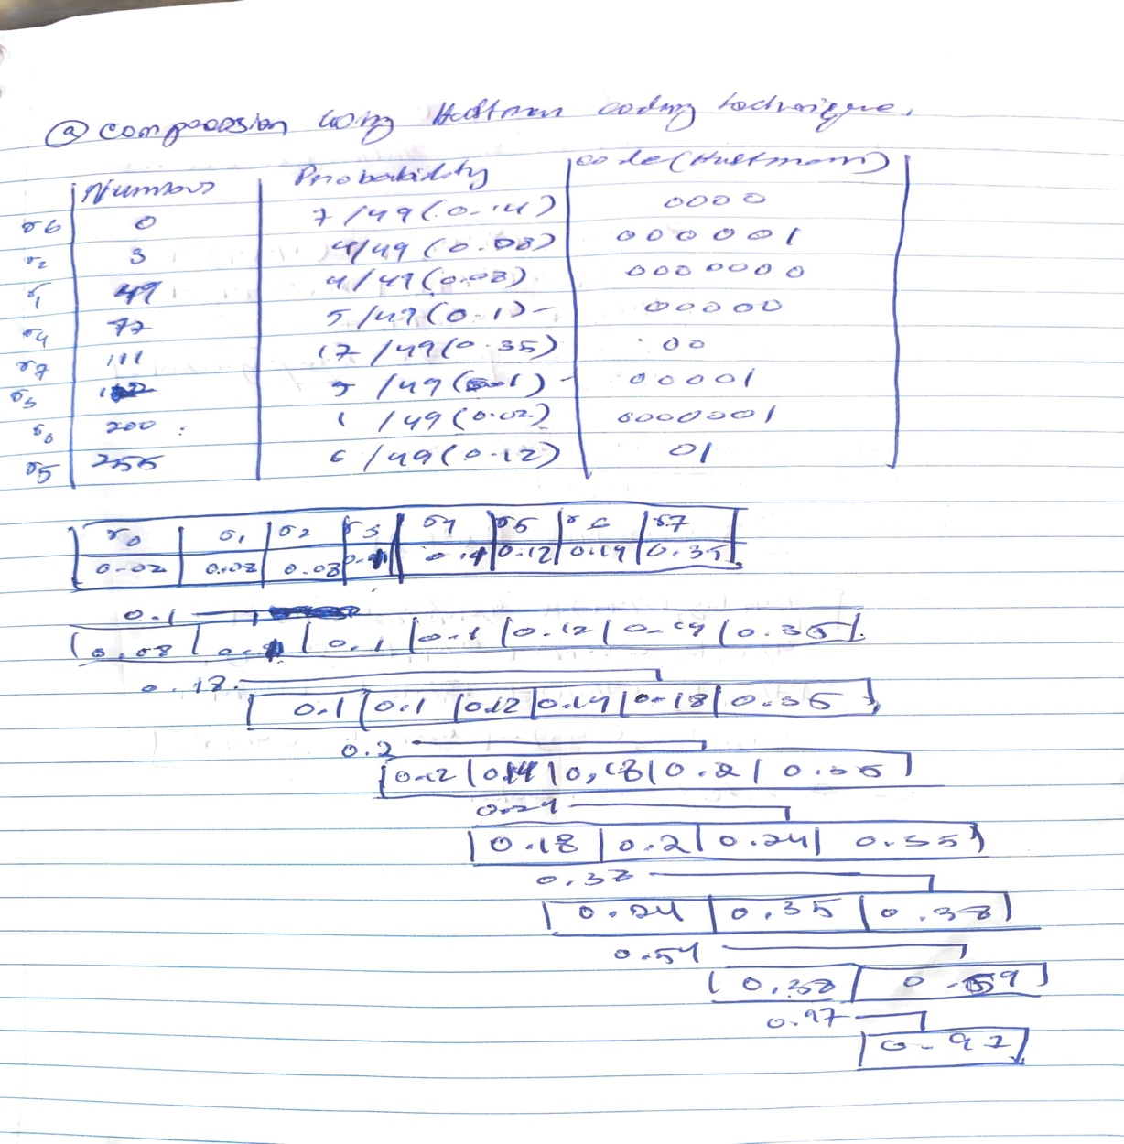

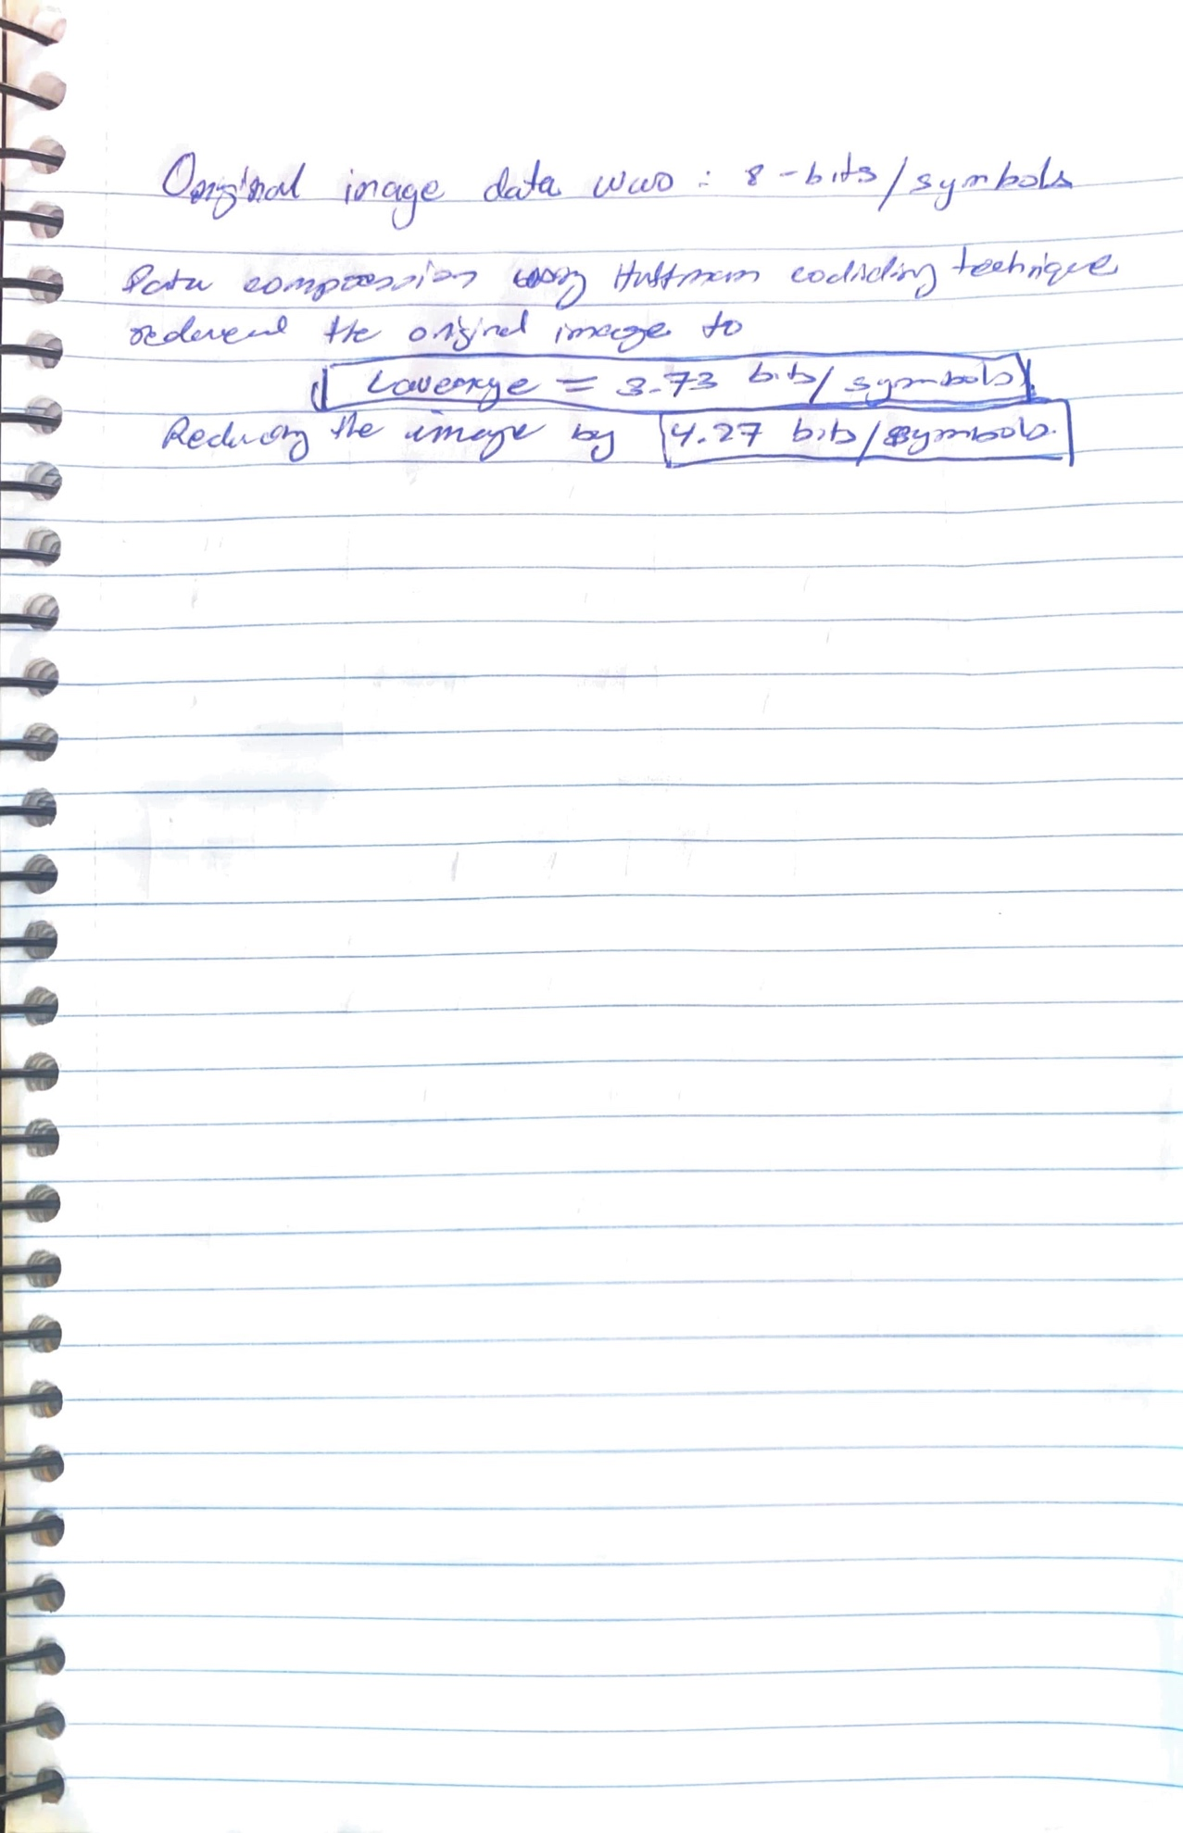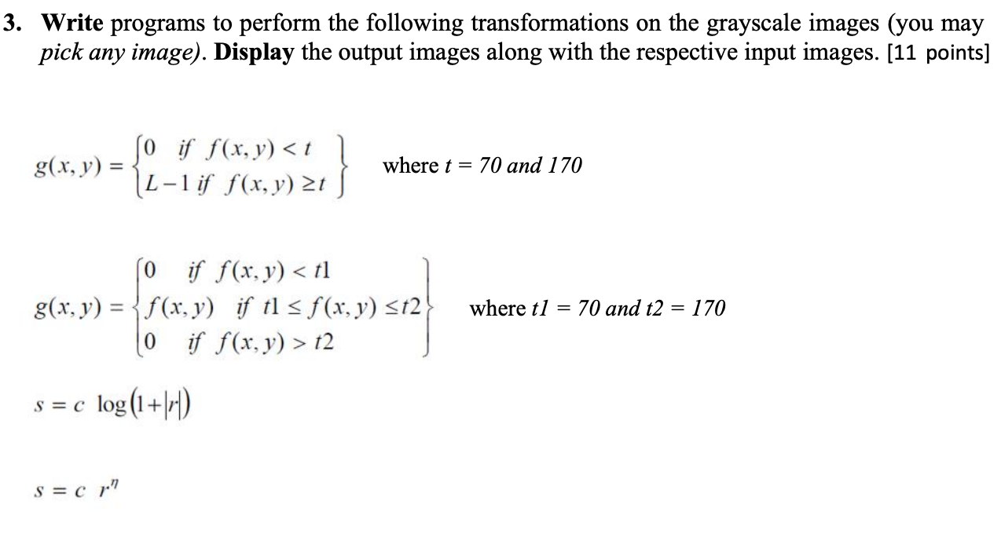

Output for:

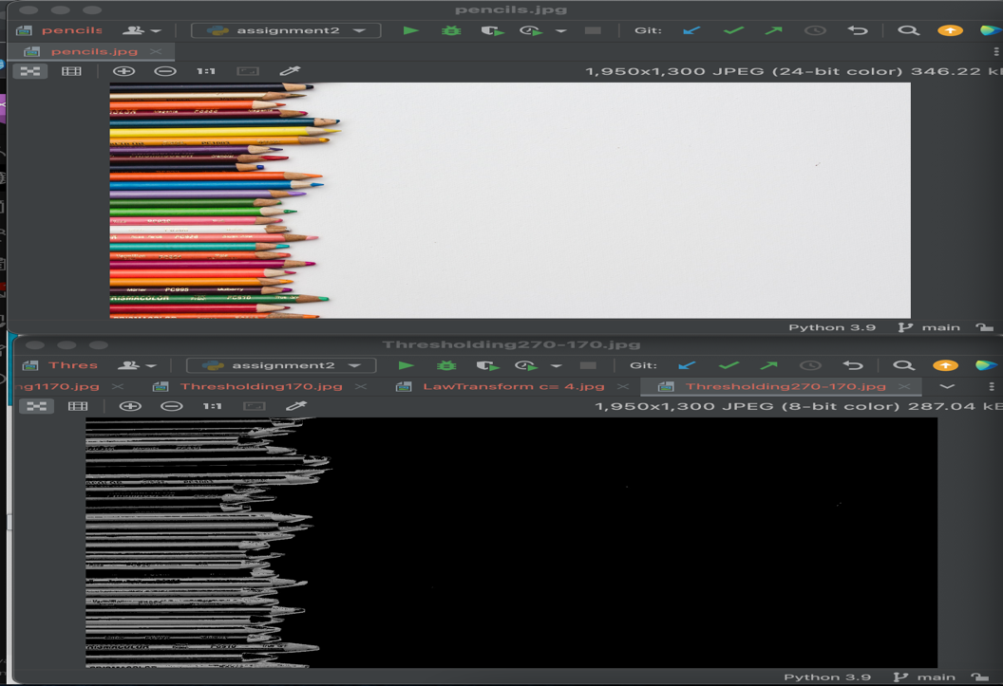

Output for:

